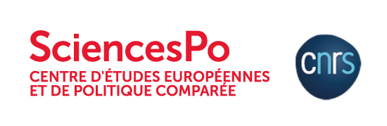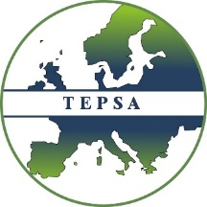

TEPSA Recommendations to the French
Presidency of the Council of the European Union
On 09 December 2021, the TEPSA Recommendations to the incoming French Presidency of the Council of the EU were presented to David Cvach.

PARIS, 10/12/2021: On the occasion of TEPSA’s French Pre-Presidency Conference, the TEPSA Recommendations to the upcoming French Presidency of the Council of the European Union were formally presented to David Cvach from the French Ministry of Foreign Affairs by Dr. Nicoletta Pirozzi (IAI, Italy), Dr. Funda Tekin (IEP, Germany), and Dr. Ilke Toygür (Elcano, Spain).

The main message of the TEPSA Recommendations is that one of the key issues for the upcoming leadership of the Union is how to Europeanize the French Presidency – meaning, how to make sure that European priorities and solutions put forth by the French Presidency respond to wider European, and not merely French, interests and views. In the meantime, reinforcing the Franco-German alliance will also be on the table since Germany is getting ready to send its new leader to the European Council. Three areas are going to be extremely important. Defining what “strategic autonomy” should entail; the execution of the recovery fund; and converting the results of the Conference on the Future of Europe into something tangible.

Further recommendations were discussed with researchers from the TEPSA Network. Francesco Saraceno (Sciences Po OFCE) calls on the French Presidency to create a central fiscal capacity to build a Europe better equipped to deal with future challenges; Héctor Sánchez Margalef (Barcelona Centre for International Affairs & TEPSA) urges the French Presidency to enhance the EU’s influence in the Southern neighbourhood and adjacent regions (Sahel, Horn of Africa, Arabian Peninsula) as well as bringing the Mediterranean higher on the EU agenda. Finally, Roderick Parkes (German Council on Foreign Policy & TEPSA) calls on the French Presidency to focus on transforming the EU into a military-strategic actor, since the Strategic Compass is due to be endorsed by the European Council in March Next year.

Upon reading the Recommendations, Mr Cvach commented: We don't want to use our Presidency to push our agenda down the throats of the other Member States. But Europe is about cooperation, about taking a higher view than the national interest […] your TEPSA Recommendations may actually prove to be followed by the French Presidency. Jim Cloos, Secretary-General of TEPSA encouraged the French Presidency to face challenges head-on: "You have to hope for the best, and then take what comes".

-ENDS-
Press inquiries to: hugh.evans@tepsa.eu

